24 cm Electroroast®
This electric unit is perfect for students and a small family. Whether you only have a small stove-top, you enjoy travelling, or often need to transport food, this unit is versatile in use and convenient on electricity. Simply plug it in to an electrical outlet and start cooking! Use it to make a variety of smaller meals, from soups to stews and succulent roasts.
For students or travelers this unit replaces an oven and allows you to cook on the go or in a small space.

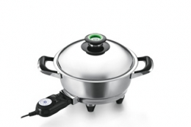

Features

Specifications
* 8 cm height
* 3,2 litre capacity

Usage
* ideal for “one-pot” meals
* convenient to transport and reheat food
* perfect for small kitchens

